Poznan University of Medical Sciences | 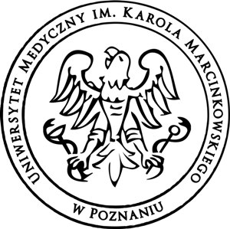

Call for Applications - Scholarship Programme

Closing date: July 10th , 2017

Introduction
Poznan University of Medical Sciences introduces open competition for 2 months (August -September 2017) scholarship programme. It enables successful applicants to realize research project.

Eligibility
The programme is dedicated to:
- Students who are currently studying their next to the last or last year of studies,
- Young researchers - maximum 3 years after graduation.

Financial matters:
- Scholarship in the amount of 1000PLN/month,
- Accommodation in the university dormitory – free of charge,
- Travel costs up to 1000PLN (in case of reasonable explanation University could refund more).

Application Procedure:
Candidates should supply the following letters/ documents:

- Application form;

- A personal statement indicating why they wish to apply for this scholarship and the likely benefit to them and their medical university should they be successful with their application;

- Graduates: verified* copy of the university diploma;

- Students: transcript of records;

- Scientific achievements (publications, prizes, etc.);

- Verified* copy of the at least B2 English language certificate - Cambridge English: First or other certificate being submitted as evidence of satisfactory mastery of the English language.

- A letter of support written in English from the Rector /Vice-Rektor of the applicant’s University /Research Institute;

- In case of Polish ancestry: document which will proof it;

- Qualified candidates will be obliged to show valid hepatitis B immunization certificate.

*verified” means that the copy of the document is a true copy of the original. Confirmation from their Dean or Rector’s Office will be accepted.

Polish Documents do not require to be translated into English in this instance.

For enquiries about applying for the scholarship, please contact:

Mrs. Bozena Raducha
Head of the International Relations Office
Poznan University of Medical Sciences
10 Fredry Street
61-701 Poznan, Poland

E-mail: braducha@ump.edu.pl

