UDC 617.7-073.178
Eliseeva Е.Е.¹, Petrova P.P.¹
CELLULAR IMMUNE RESPONSE IN PATIENTS WITH SEVERE BACTERIAL INFECTION
Scientific supervisors: PhD in Medical sciences, Associate Professor Ivanov I.I.¹, Egorov Е.Е.² (the anesthesiologist)
¹ Vitebsk State Order of Peoples’ Friendship Medical University, Vitebsk
²Vitebsk Regional Clinical Hospital, Vitebsk

Abstract. Text text text text text text text text text text text text text text text text text text text text text text text text text text text text text text text text text text text text text text text text text text text text text text text text text text text text text text text text text text text text text text text text text text text text text text text text text text text text text text text text text text text text text text text text text text text text text text text text text text text text text text text text text text text text text text text text text text text text text text text.
Keywords: cellular immunity, lymphocyte blast transformation reaction, intensive care unit.
Introduction. Text text text text text text text text text text text text text text text text text text text text text text text text text text text text text text text text text text text text text text text text text text text text text text text text text text text text text text text text text text text text text text text text text text text text text text text text text [1]. Text text text text text text text text text text text text text text text text text text text text text text text text text text text text text text text text text text text text text text text text text text text text text text text text text text text text text text text text text text text text text text text text text text text text text [2].
Purpose of the study. Text text text text text text text text text text text text text text text text text text text text text text text text text text text text text text text text text text text text text text text text text text text text text text text text text text text text text text text text text text text text text text text text text.
Material and methods. Text text text text text text text text text text text text text text text text text text text text text text text text text text text text text text text text text text text text text text text text text text text text text text text text text text text text text text text text text text text text text text text text text.
Results of the study. Text text text text text text text text text text text text text text text text text text text text text text text text text text text text text text text text text text text text text text text text text text text text text text text text text text text text text text text text text text text text text text text text text (table 1).
Text text text text text text text text text text text text text text text text text text text text text text text text (illustration 1).
Table 1. Antimicrobial activity of EM against reference strains of microorganisms from the ATCC collection (% growth inhibition)
Microorganism | х | а | в
Quantity /antibiotic | 4 | 5 | 6
Ampicillin | 100 | 100 | 92
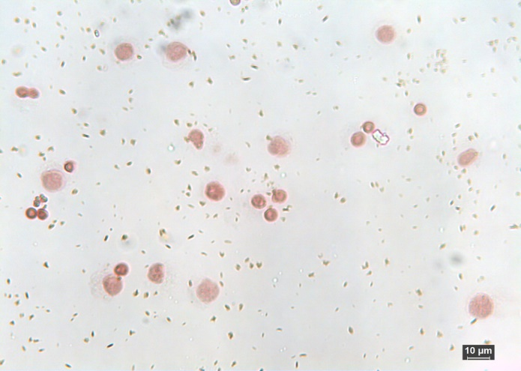
Illustration 1. Microscopy of a suspension of donor blood lymphocytes and lymphoblasts during the RBL test with FGA
Conclusion. Text text text text text text text text text text text text text text text text text text text text text text text text text text text text text text text text text text text text text text text text text text text text text text text text text text text text text text text text text text text text text text text text text text text text text text text text.
Literature:
- Risk factors for intraocular pressure rise following / M. Coban-Karatas, S. Sizmaz, R. Altan-Yaycioglu [et al.] // Ind. J. of Ophtalm. − 2020. − Vol. 61, №3. − P. 115−118.
- Особенности гидродинамики глаза после факоэмульсификации у пациентов с первичной открытоугольной глаукомой / Е. А. Калижникова, О.И. Лебедев, О.В. Щипачева, Г.Г. Печерица // Вестн. офтальмол. − 2022. – Т. 132, № 5. − С. 54−59.

Список литературы оформляется в соответствии приказом Высшей аттестационной комиссии Республики Беларусь от 25.06.2014 № 159 (в редакции приказа Высшей аттестационной комиссии Республики Беларусь 01.10.2024 № 230) (примеры: https://vak.gov.by/node/8026).
Порядковые номера ссылок должны быть написаны внутри квадратных скобок, например: [1].
Не более 5 источников.
Для рисунков параметр «Обтекание текстом» выбирается «В тексте», выравнивание – по центру без отступа абзаца.

